**AI Roadside Vendors & Illegal Parking**

**Detection System**

**(Artificial Intelligence Project)**



Session: 2022 – 2026

**Submitted by:**

Shehroz Ahmad 2022-CS-157

Muhammad Saad Akmal 2022-CS-148

**Supervised by:**

Sir Samyan Qayyum Wahla

Department of Computer Science

**University of Engineering and Technology**

**Lahore Pakistan**

Table of Contents

1. Introduction: 4

1.1. Purpose: 4

1.2. Scope: 4

1.3. Definitions, Acronyms, and Abbreviations: 4

1.4. References: 4

1.5. Overview: 4

2. Overall Description: 4

2.1. Product Perspective: 5

2.2. Product Functions: 5

2.2.1. Real-Time Detection: 5

2.2.2. Data Processing: 5

2.2.3. User Alerts and Notifications: 5

2.2.4. Managing History: 5

2.2.5. User-Friendly Interface: 5

2.2.6. User Management: 5

2.3. User Characteristics: 5

2.3.1. Education Level: 5

2.3.2. Experience: 6

2.3.3. Technical Expertise: 6

2.4. Constraints: 6

2.4.1. Regulatory Policies: 6

2.4.2. Hardware Limitations: 6

3. Specific Requirements: 6

3.1. External Interfaces: 6

3.1.1. Live Camera Feed: 6

3.1.2. User Inputs: 6

3.1.3. Alert Notifications: 7

3.2. Functional Requirements: 7

3.2.1. Admin Functional Requirements 7

3.2.2. Traffic Police Functional Requirements 8

3.3. Use Case: 8

3.3.1. Admin Sign Up and Sign In: 8

3.3.1.1. Sign Up and Sign in Interface: 8

3.3.2. View Live Videos: 9

3.3.2.1. Live Feed Interface: 9

3.3.3. Review Detected Incident: 9

3.3.3.1. Review Interface: 10

3.3.4. Confirm incident and send alerts: 10

3.3.4.1. Confirm incident and send alerts Interface: 11

3.3.5. Delete Incident: 11

3.3.5.1. Delete Incident Interafec: 12

3.3.6. View Logs: 12

3.3.6.1. Logs Interface: 13

3.3.7. Traffic Police receive alerts: 13

3.3.7.1. Alerts List Interface: 13

3.3.8. Traffic Police response: 14

3.3.8.1. Traffic Police response Interface: 14

3.4. Non-Functional Requirements: 14

# Introduction:

The SRS document will be written to define the functional and non-functional requirements of the AI Roadside Vendors and Illegal Trafficking Detection system. This document illustrates what should be in the system's design, its implementation, and testing phases.

## Purpose:

The purpose of this SRS document is to outline the functional and non-functional requirements of the system clearly. It serves as a roadmap for developers, designers, and testers, ensuring that everyone understands what the system should achieve and how it should perform.

## Scope:

This project includes developing an AI system that uses real-time camera feeds to identify unauthorized roadside vendors and illegally parked vehicles. It involves collection and training of data for accurate detection. This system can be used by city officials to improve traffic management and make cities safer and more organized.

## Definitions, Acronyms, and Abbreviations:

* **SRS:** Software Requirements Specifications
* **Real-Time Monitoring:** Delivery of continuously updated data about systems, processes or events
* **API:** Application Programming Interface
* **UI:** User Interface

## References:

* Allgo Vision. (n.d.). AI powered illegal parking detection. Retrieved from <https://www.allgovision.com/admin/uploads/datasheets/V4.3_AllGoVision_Datasheet_Illegal_Parking.pdf>
* Universiti Tun Hussein Onn Malaysia. (2023). AI-based analytics for hawkers identification in video surveillance for smart community. Journal of Technology and Science. <https://publisher.uthm.edu.my/ojs/index.php/JTS/article/view/16265>

## Overview:

The SRS document is divided into three main sections. Section 1 provides an overview of the AI Roadside Vendors and Illegal Trafficking Detection system. Section 2 details the system’s intended users, their characteristics, and any constraints they may face. Section 3 outlines the functional requirements and use cases associated with those requirements.

# Overall Description:

This section of the SRS describes the general factors influencing the AI Roadside Vendors and Illegal Trafficking Detection system and its requirements. This system will detect roadside vendors and illegally parked vehicle and then report it to the city officials.

## Product Perspective:

The product is designed as an independent solution that utilizes artificial intelligence and real-time camera feeds to detect unauthorized roadside vendors and illegally parked vehicles. Relevant projects have also been implemented before like **“AI powered Illegal Parking”** by **“Algo Vision”.** It detects vehicles parking/stopping spots beyond a specified. It monitors, detects and alerts against parking violation by generating alarms in real time. Our project is also similar to this project as that project detects vehicles parked illegally and then it triggers the alarm and our project detects the illegally parked vehicles and then report it to the city officials. The difference between their project and our project is that their project covers the parking area and our project covers the roadside area.

## Product Functions:

The system can perform the following functionalities:

### Real-Time Detection:

The system will utilize AI algorithms to analyze live camera feeds and identify unauthorized roadside vendors and illegally parked vehicles instantly.

### Data Processing:

The system will process video data to extract relevant features and classify objects, ensuring accurate detection.

### User Alerts and Notifications:

The system will generate real-time alerts for city officials when illegal vendors or parking violations are detected, enabling quick response and enforcement actions.

### Managing History:

The system will maintain the history of previously detected violations, including timestamps, locations and images.

### User-Friendly Interface:

The system will provide an intuitive web-based dashboard for city officials to access detection results, view live camera feeds, and manage previous data.

### User Management:

The system will allow for role-based access control, enabling different levels of access for city officials and administrators based on their responsibilities.

## User Characteristics:

This subsection describes the general characteristics of the intended users of the AI Roadside Vendors and Illegal Trafficking Detection system.

### Education Level:

Users typically possess at least a bachelor’s degree, often in fields related to urban planning, public administration, or law enforcement. This educational background provides them with a foundational understanding of urban management.

### Experience:

Users are generally experienced city officials or traffic management authorities with several years of experience in their respective fields. The need of specific training in AI or machine learning is not required.

### Technical Expertise:

Users are expected to have a basic understanding of computer systems and applications and also familiarity with standard office software like spreadsheets, databases etc., but may not have extensive technical skills in programming or data science.

## Constraints:

This subsection outlines the general constraints that will limit the development options for the AI Roadside Vendors and Illegal Trafficking Detection system:

### Regulatory Policies:

The system needs to follow local and national laws about surveillance and data privacy. This means getting the right permits to install cameras and making sure it follows rules about collecting and using personal information.

### Hardware Limitations:

The system's performance might be affected by the type of hardware used, especially the cameras and processing equipment. To detect vendors and illegally parked vehicles in real-time, the system needs high-quality cameras and powerful processors to avoid delays.

# Specific Requirements:

This section of the SRS should contain all of the software requirements to a level of detail sufficient to enable designers to design a system to satisfy those requirements, and testers to test that the system satisfies those requirements.

## External Interfaces:

This section provides a detailed description of the inputs into and outputs from the AI Roadside Vendors and Illegal Trafficking Detection system.

### Live Camera Feed:

* **Description:** Captures real-time video footage for processing to detect unauthorized vendors and illegally parked vehicles.
* **Source of Input:** Installed surveillance cameras at strategic locations.
* **Relationships to Other Inputs/Outputs:** Feeds into the AI detection algorithm for analysis.

### User Inputs:

* **Description of Purpose:** Allows users to interact with the system, such as reviewing, deleting or changing status
* **Source of Input:** User interactions through the web interface.
* **Relationships to Other Inputs/Outputs:** Affects how data is displayed and processed.

### Alert Notifications:

* **Description:** Notifies users of detected violations in real-time.
* **Source of Input:** Triggered by the AI detection system upon identifying a violation.
* **Relationships to Other Inputs/Outputs:** Related to camera input; requires accurate processing of live feeds.



## Functional Requirements:

The functional requirements of the AI Roadside Vendors and Illegal Trafficking Detection system define the core actions it must perform to handle inputs and produce outputs effectively. Below are the key functions:

### Admin Functional Requirements

1. **Admin Sign Up and Sign In:**

* If no admin exists, the first admin can sign up.
* Admin shall sign in only if one admin is already added.

1. **Admin Views Live Videos:**

* Admin shall view live videos from the cameras.

1. Admin Reviews the detected incident:

* Admin shall review the incident detected by the AI, including details such as:
  + Location
  + Time
  + Snapshot or small video of the incident

1. **Admin Confirms the incident:**

* After reviewing the admin shall confirm the happening of the incident and after that an alert will be sent to the traffic authorities including
  + Location
  + Time
  + Snapshot or small video of the incident

1. **Admin Deletes the incident:**

* Admin can delete an incident in case it was detected as false by the AI or it was not relevant.

1. **Admin View the Log:**

* Admin shall view a list of logs of past incidents along with timestamp, location and the resolution status.

### Traffic Police Functional Requirements

### Traffic Police receive alerts:

* Traffic police will receive and email or message with the details.

### Traffic Police Response:

* Traffic police shall mark the incident as “Resolved” after completing them on field.



## Use Case:

### Admin Sign Up and Sign In:

* **Primary Actors:** Admin
* **Preconditions:** The system has no admin registers (Sign Up) or an admin account already exists.
* **Main Success Scenarios:**

1. If admin is not already registered, admin can register after providing the necessary details.
2. If admin account exists, sign in by providing email and password.

* **Post Scenario:** Admin gains access to the system.
* **Exceptions:** If an admin already exists then new users cannot sign up and the system will signal with an error.

### Sign Up and Sign in Interface:

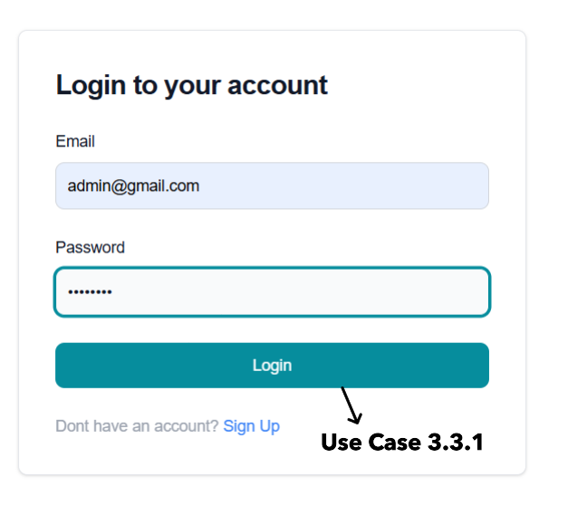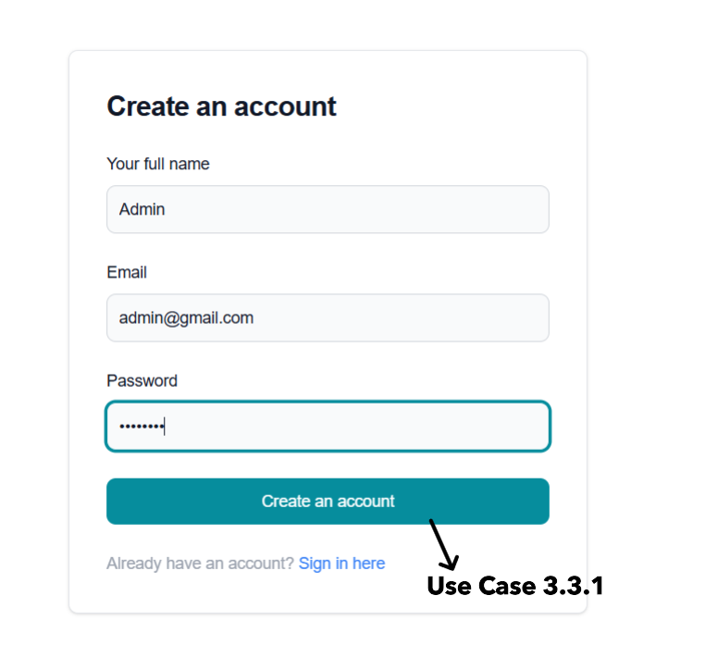

Figure 1b Sign-In Page

Figure 1a Sign-Up Page

### View Live Videos:

* **Primary Actors:** Admin
* **Preconditions:** Admin is logged in.
* **Main Success Scenarios:**

1. Admin navigates to the live feed section.
2. The system displays the live video from the installed cameras monitoring traffic.

* **Post Scenario:** Admin can view and monitor live traffic.
* **Exceptions:** Video feed may fail to load due to cameras or network issues causing system to signal an error.

### Live Feed Interface:

Figure 2 Live Feed

### Review Detected Incident:

* **Primary Actors:** Admin
* **Preconditions:** The system has detected and incident (illegal parking or a vendor blocking a road).
* **Main Success Scenarios:**

1. The AI flags the system with incident detected.
2. The admin is notified via dashboard about the incident.
3. The admin reviews the incident details, including location, timestamp or snapshot of a video.

* **Post Scenario:** Admin reviews the detected incident.
* **Exceptions:** The incident detection could be wrong, delayed or flagged incorrectly.

### Review Interface:

Figure 3 Incident Review

### Confirm incident and send alerts:

* **Primary Actors:** Admin
* **Preconditions:** The admin has reviewed an incident.
* **Main Success Scenarios:**

1. The admin confirms the incident.
2. System sends the alert via message or email including details of the incident.

* **Post Scenario:** The traffic police are notified about the incident.
* **Exceptions:**

1. Admin may not confirm the incident due to its irrelevance.
2. Notification may fail to send due to network or other issues which will trigger an error.

### Confirm incident and send alerts Interface:

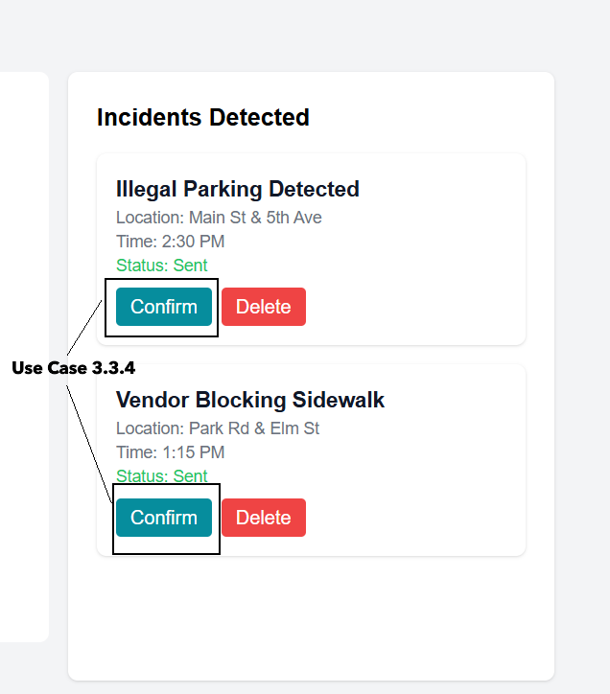

Figure 4 Incidents List with confirm scenario

### Delete Incident:

* **Primary Actors:** Admin
* **Preconditions:** An incident was falsely flagged or was irrelevant.
* **Main Success Scenarios:**

1. Admin view an irrelevant incident and decides to delete.
2. Admin deletes the incident from the dashboard.

* **Post Scenario:** The incident will be deleted.
* **Exceptions:** 
  1. If admin deletes a relevant incident, it will not be recoverable.
  2. The deleting process may fail which will show an error.
  3. The admin may try to delete a feed or an incident which does not exist which will cause system to notify user with appropriate message.

### Delete Incident Interafec:

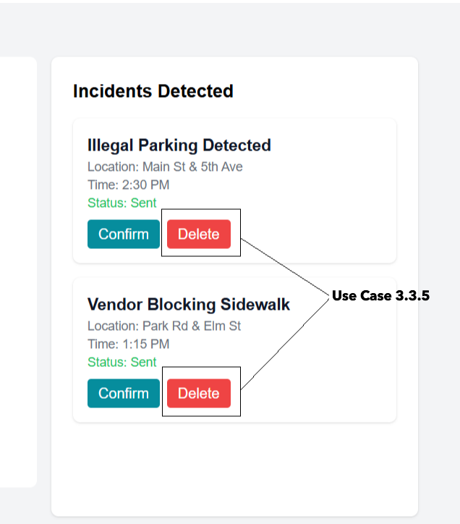

Figure 5 Incidents List with delete scenario

### View Logs:

* **Primary Actors:** Admin
* **Preconditions:** Admin is logged in.
* **Main Success Scenarios:**

1. Admin navigates to the logs.
2. System displays the list of past incidents with timestamp, location and resolution status (sent, resolved, etc.).

* **Post Scenario:** Admin view the complete log of past incident.
* **Exceptions:** The logs may not appear due to network issues or data being corrupted which will cause the system to throw an error.

### Logs Interface:

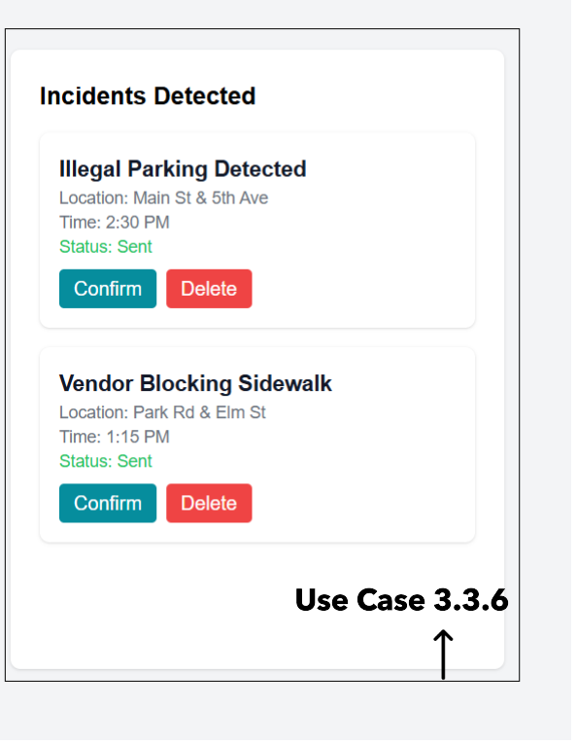

Figure 6 Incidents List

### Traffic Police receive alerts:

* **Primary Actors:** Traffic Police
* **Preconditions:** Admin confirms the incident and send alerts.
* **Main Success Scenarios:**

1. Traffic police receives the message or email with incident details.

* **Post Scenario:** Traffic police receives the information to respond to the incident.
* **Exceptions:** Alerts my not be received due to the network or other issue that will cause the system to signal with ‘Network error’.

### Alerts List Interface:

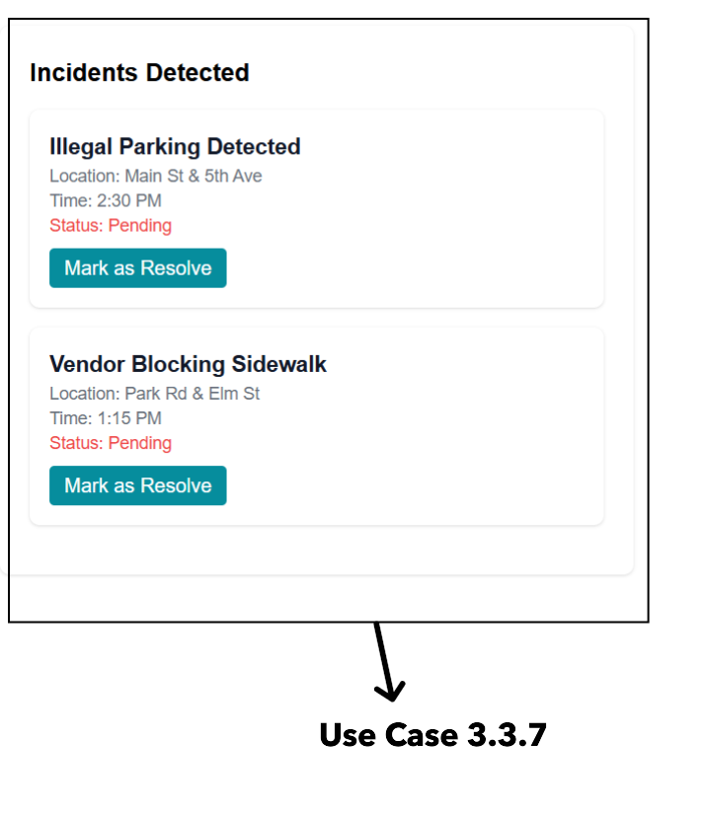

Figure 7 Traffic Police Alerts

### Traffic Police response:

* **Primary Actors:** Traffic Police
* **Preconditions:** Traffic police resolved the incident on the field.
* **Main Success Scenarios:**

1. Traffic police marks the incident as resolved.
2. The system updates the logs and change the incident status.

* **Post Scenario:** The incident is marked as resolved.
* **Exceptions:** 
  1. Police may forget to change the status leaving it pending.
  2. The system might fail to update the status in this an error will be thrown.

### Traffic Police response Interface:

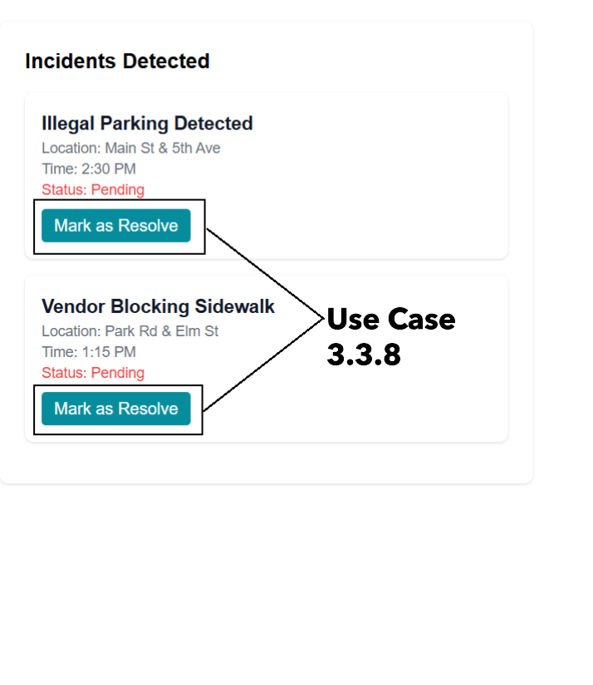

Figure 8 Case resolve Scenario



## Non-Functional Requirements:

* The system should detect and flag the incident within one minute.
* The alert to police will be send within one minute after the confirmation by the admin.
* Only admin and authorized traffic police officers will have access to the system.
* The system should be responsive and accessible to the admin and traffic police on mobile and desktop.